EMPTY JTable component NORTH PART OF BLM

FIRST SCREEN OF MORTGAGE CALCULATOR GUI(BORDER LAYOUT VERSION)
JFrame Label

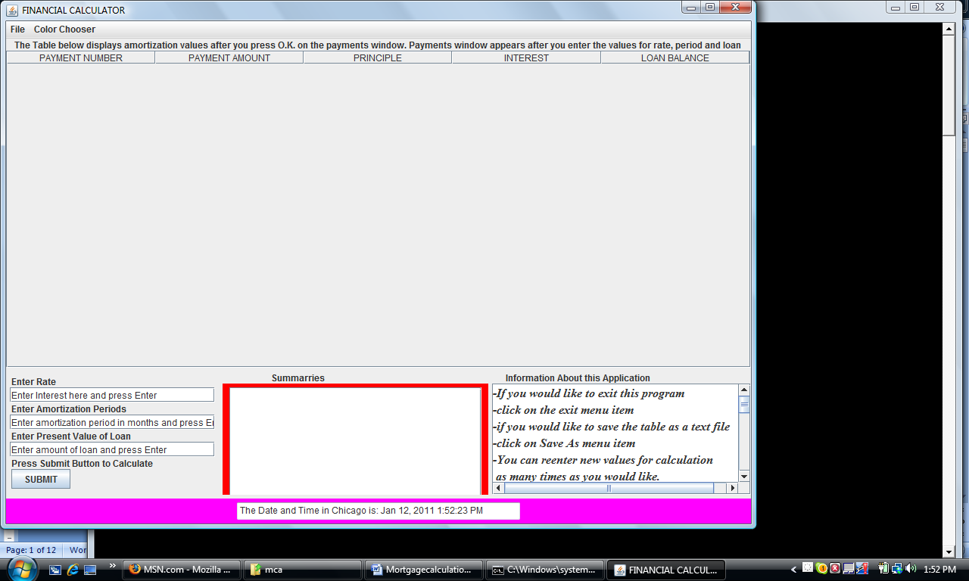
CENTER PART OF BLM (consists of 3 horizontal parts)
Names of Columns
Menu Bar

SOUTH PART OF BLORDER LAYOUT MANAGER (BLM)
3 JTextFields and a JButton Boxed vertically

//Author: George Koutsogiannakis
//Institution: Illinois Institute of Technology
//Copying and usage for any other reason other than educational
//is prohibited without the author's explicit authorization in writing.

//Date: 01/14/03
//updated 5/17/05
// updated 8/25/05
//correction to index in paintComponent made 1/29/06

import javax.swing.*;
import java.text.DecimalFormat;
import java.awt.Graphics;
import java.awt.*;
import java.awt.event.*;
import javax.swing.table.*;
import java.io.*;
import java.util.*;
import java.text.NumberFormat;
import java.text.DateFormat;

public class Mortgagecalculation extends JFrame
{

//global declarations. Values are accessible by all methods

String interest;
static double interestnumber;
String time="0";
String loanamount;
String result;
String string;
static double timenumber;
double decimalinterestnumber;
static double loannumber;
static double payment;
double z;
double x;
double a;
double y;
static double totalpayments;
static double totalinterest;
static double principlek;
static double balance;
static Vector buffer=new Vector(30,50);
Color color;
Container c;
DecimalFormat twodigits = new DecimalFormat("0.00");
double loannumberk;
DefaultTableModel mydefaulttable;
JTable mytable;
int k, l;
JTextField loanamountfield, interestfield, timenumberfield;
JTextArea centerarea;
JButton submitbutton;
int paintindex=0,index=0,m=0, temp;

NumberFormat moneyFormat=NumberFormat.getCurrencyInstance(Locale.US);

//default constructor
public Mortgagecalculation()
{

}

public Mortgagecalculation (String label)
{
super(label);
constructGUI();
}
public void constructGUI()
{

c= getContentPane();

//Construct the menus and their listeners

JMenu filemenu = new JMenu("File");
JMenuItem saveas= new JMenuItem ("Save Amortization As");
saveas.addActionListener(new ActionListener(){
public void actionPerformed (ActionEvent e)
{
JFileChooser filechooser = new JFileChooser ();
filechooser.setFileSelectionMode ( JFileChooser.FILES_ONLY);
int result = filechooser.showSaveDialog (null);
if (result== JFileChooser.CANCEL_OPTION)

{
return;
}
File filename = filechooser.getSelectedFile();
if (filename==null||filename.getName().equals (" "))
{
JOptionPane.showMessageDialog( null, "Invalid File Name", "Invalid FileName", JOptionPane.ERROR_MESSAGE );
}
else {
try
{

System.out.println("I am ready to create the streams");

FileOutputStream file = new FileOutputStream(filename, true);

OutputStreamWriter filestream = new OutputStreamWriter(new BufferedOutputStream(file));

String info= "The data is based on"+"\n";

filestream.write(info);

System.out.println("I wrote the first string called info");

String interestdata= "INTEREST:"+" "+interest+"\n";
filestream.write(interestdata);
String timedata="The amortization period is:"+" "+time+"\n";
filestream.write(timedata);
String loandata="The money borrowed is:"+" "+moneyFormat.format(loannumber)+"\n";
filestream.write(loandata);
String totals= "Total of Payments Made:"+" " +moneyFormat.format(totalpayments)+"\n"+"Total Interest Paid:"+" "+moneyFormat.format(totalinterest)+"\n";
filestream.write(totals);

String filestring = "PAYMENT NUMBER"+" " + "PAYMENT" + " " + " PRINCIPLE" + " " + "INTEREST" +" " + " BALANCE" + "\n";
filestream.write(filestring);
double loannumberkf= loannumber;
System.out.println(timenumber);

for (int j=1; j<=timenumber ; j++ )
{

double principlekf=payment-loannumberkf*z;
double balancef=loannumberkf-principlekf;
String display ="\n"+ Integer.toString(j)+" " + moneyFormat.format(payment)+" "+ moneyFormat.format(principlekf)+ " "+moneyFormat.format(loannumberkf*z)+ " "+ moneyFormat.format(balancef)+"\n";
filestream.write(display);
loannumberkf=loannumberkf-principlekf;

}
filestream.flush();
file.close();
}
catch ( IOException ioException )
{
JOptionPane.showMessageDialog (null, "File Does not exist", "Invalid File Name", JOptionPane.ERROR_MESSAGE);
}

}//end of else

}
} //end anonymous inner class
);
filemenu.add(saveas);
JMenuItem exit= new JMenuItem ("Exit");
exit.addActionListener( new ActionListener() {
public void actionPerformed (ActionEvent e)
{
System.exit(0);
}
} //end anonymous inner class
); // end call to ActionListener
filemenu.add(exit);

JMenuItem summaries=new JMenuItem ("Save Summaries As");
MenuHandler menuhandler= new MenuHandler();
summaries.addActionListener(menuhandler);
filemenu.add(summaries);

//construct the second JMenu

JMenu colorchooser=new JMenu("Color Chooser");
JMenuItem colorchooseritem=new JMenuItem("Choose Color");
colorchooseritem.addActionListener (new ActionListener() {
public void actionPerformed(ActionEvent e)
{
color=JColorChooser.showDialog(Mortgagecalculation.this, "Choose a Color", color);
c.setBackground(color);
c.repaint();
}
}
); //end of registration
colorchooser.add(colorchooseritem);

//Create menu bar and add the two JMenu objects
JMenuBar menubar = new JMenuBar();
setJMenuBar(menubar);
menubar.add(filemenu); // end of menu construction
menubar.add(colorchooser);

//set the layout manager for the JFrame
c.setLayout(new BorderLayout(5,5));

//construct table and place it on the North part of the Frame
JLabel tablelabel=new JLabel ("The Table below displays amortization values after you press O.K. on the payments window. Payments window appears after you enter the values for rate, period and loan");
mydefaulttable = new DefaultTableModel();
mydefaulttable.addColumn("PAYMENT NUMBER");
mydefaulttable.addColumn ("PAYMENT AMOUNT");
mydefaulttable.addColumn ("PRINCIPLE");
mydefaulttable.addColumn ("INTEREST");
mydefaulttable.addColumn("LOAN BALANCE");

Box tablebox=Box.createVerticalBox();
mytable=new JTable(mydefaulttable);
tablelabel.setLabelFor(mytable);

JScrollPane myscrollpane= new JScrollPane (mytable);

tablebox.add(tablelabel);
tablebox.add(myscrollpane);
c.add (tablebox, BorderLayout.NORTH);

//create center panel

JLabel panellabel=new JLabel("Summarries");
MyPanel panel =new MyPanel();
panel.setSize (10, 50);

panel.setBackground(Color.red);
panellabel.setLabelFor(panel);

Box panelbox=Box.createVerticalBox();
panelbox.add(panellabel);
panelbox.add(panel);
c.add (panelbox, BorderLayout.CENTER);

//add time in the SOUTH part of the Frame

Panel southpanel=new Panel();
southpanel.setBackground(Color.magenta);

Date time=new Date();
String timestring=DateFormat.getDateTimeInstance().format(time);

TextField timefield=new TextField("The Date and Time in Chicago is:"+" "+timestring, 50);
southpanel.add(timefield);
c.add(southpanel, BorderLayout.SOUTH);

//USE "BOX LAYOUT MANAGER" TO ARRANGE COMPONENTS LEFT TO RIGHT WITHIN THE SOUTH PART OF THE FRAME

//Create a text area to output more information about the application.Place it in a box and place box EAST

Font f=new Font("Serif", Font.ITALIC+Font.BOLD, 16);

string="-If you would like to exit this program\n"+
"-click on the exit menu item \n"+
"-if you would like to save the table as a text file \n"+
"-click on Save As menu item \n"+"-You can reenter new values for calculation\n"+
" as many times as you would like.\n"+
"-You can save the summaries also on a different file\n"+
"-Files are appended";

JLabel infolabel= new JLabel ("Information About this Application", JLabel.RIGHT);
JTextArea textarea=new JTextArea(25,25);
textarea.setFont(f);
textarea.append(string);
infolabel.setLabelFor(textarea);
Box box =Box.createVerticalBox();
box.add(infolabel);
box.add(new JScrollPane (textarea));
c.add(box, BorderLayout.EAST);

//Create the text fields for entering data and place them in a box WEST

Panel panelwest = new Panel();

//create the first panelwest and place the text fields in it
Box box1=Box.createVerticalBox();
JLabel rate= new JLabel ("Enter Rate", JLabel.RIGHT);
interestfield=new JTextField ("Enter Interest here and press Enter", 15);
rate.setLabelFor(interestfield);
box1.add(rate);
box1.add(interestfield);
JLabel period=new JLabel("Enter Amortization Periods", JLabel.RIGHT);
timenumberfield=new JTextField("Enter amortization period in months and press Enter", 15);
period.setLabelFor(timenumberfield);
box1.add(period);
box1.add(timenumberfield);
JLabel loan=new JLabel("Enter Present Value of Loan", JLabel.RIGHT);
loanamountfield =new JTextField ("Enter amount of loan and press Enter", 15);
loan.setLabelFor(loanamountfield);
box1.add(loan);
box1.add(loanamountfield);
JLabel submit = new JLabel("Press Submit Button to Calculate", JLabel.RIGHT);
submitbutton= new JButton("SUBMIT");
submit.setLabelFor(submitbutton);
box1.add(submit);
box1.add(submitbutton);
panelwest.add(box1);

//Add the panel to the content pane
c.add(panelwest, BorderLayout.WEST);

//Event handler registration for text fields and submit button

TextFieldHandler handler=new TextFieldHandler();
interestfield.addActionListener(handler);
timenumberfield.addActionListener(handler);
loanamountfield.addActionListener(handler);
submitbutton.addActionListener(handler);
setSize(1000, 700);
setVisible(true);

System.out.println("repainting table, constructor");

System.out.println("I finished repainting. End of ConstructGUI");

} // END OF CONSTUCTGUI

public void calculate()
{
//This method is called after the listener handler for the text fields has been activated.
decimalinterestnumber=interestnumber*0.01;
System.out.println(decimalinterestnumber);
z= decimalinterestnumber/12;
a= (1+z);
System.out.println(a);
x= Math.pow( a, timenumber);
System.out.println(timenumber);
System.out.println(x);
y= 1- (1/x);
payment= (loannumber*z) / y;
System.out.println(payment);
//Format the payment number two a two digit format to the right of the decimal point.
//Class decimalFormat belongs to package java.text

//save timenumber everytime a new data is submitted by user

result="Your montly payment is:"+" "+"$"+" "+twodigits.format(payment);
JOptionPane.showMessageDialog(this, result , "MONTLY PAYMENT" , JOptionPane.INFORMATION_MESSAGE);
System.out.println("I am done with dialog box and now I am going to paint, I am inside calculate method now");
paintindex++;
if (paintindex>=1)
{

repaint();
}
//call to the paint methods is being made (both paint and paintComponent methods)
//the effect is that the paint method passes the values to the JTable and paintComponent method
//passes the values to the center panel on the south part.
//we want to capture the value of index at the time calculate was called.
temp=index;
}

public static void main (String args[] )
{
Mortgagecalculation m=new Mortgagecalculation("FINANCIAL CALCULATOR");
m.setDefaultCloseOperation(JFrame.EXIT_ON_CLOSE);

}

public void paint(Graphics g)
{

super.paint(g);

System.out.println("repainting, inside paint method");

//Pass the values to the table model after the calculations have been performed.
int l=mydefaulttable.getRowCount();
System.out.println(l);

loannumberk=loannumber;

for (k=1; k<=timenumber ; k++ )
{

principlek=payment-loannumberk*z;
balance=loannumberk-principlek;
String[] display = { Integer.toString(k), moneyFormat.format(payment), moneyFormat.format(principlek), moneyFormat.format(loannumberk*z), moneyFormat.format(balance)};

loannumberk=loannumberk-principlek;
if (paintindex==1)
{
//adds a row to the end of the model
mydefaulttable.addRow(display);
}

else if(paintindex>1&&k<l)

{

mydefaulttable.setValueAt(Integer.toString(k), k-1, 0);
mydefaulttable.setValueAt(moneyFormat.format(payment), k-1, 1);
mydefaulttable.setValueAt(moneyFormat.format(principlek), k-1, 2);
mydefaulttable.setValueAt(moneyFormat.format(loannumber*z), k-1, 3);
mydefaulttable.setValueAt(moneyFormat.format(balance), k-1, 4);

}//end of else if
else if (paintindex>1&&k>l)
{
mydefaulttable.addRow(display);

}
} //end of for loop
System.out.println(k);

//get rid of duplicate rows added every time the mouse clicks. Mouse clicks cause new calls to paint and repaint!!
//restrict rows to the number of periods the user entered. We can also use repaint index to restrict repainting of table
//since repaint index represents the lgitimate number of calls to calculate() method
m=Integer.parseInt(time);
mydefaulttable.setRowCount(m);

System.out.println("new payment, I am inside paint method"+payment);

} //end of paint method

class MyPanel extends JPanel
{

//Vector buffer=new Vector(30,50);

public MyPanel()
{
centerarea= new JTextArea(10,30);
JScrollPane textscrollpane= new JScrollPane (centerarea);
add(textscrollpane);

}

public Vector createBuffer()
{

totalpayments=timenumber*payment;
totalinterest = totalpayments-loannumber;

buffer.addElement("\n"+"Given the interest:"+" "+interestnumber);
buffer.addElement("and the loan amount of"+" "+moneyFormat.format(loannumber));
buffer.addElement("over the period of" + " "+timenumber+" "+"months");
buffer.addElement("The total payment is :"+" "+moneyFormat.format(totalpayments));
buffer.addElement("The total interest paid is :"+" "+moneyFormat.format(totalinterest));
buffer.addElement("--------------------");
return buffer;
}
//Paint method for panel container
public void paintComponent (Graphics g)
{
super.paintComponent(g);
index++;
//index counts the number of times paint component has been called.
//temp ha scaptured the value of index at the time the call to calculate was made
//subtract 1 from index because paintComponent is called one more time after calculate()
if(paintindex>=1&&(index-1)==temp)
{

System.out.println("the value of paintindex inside paintComponent:"+paintindex);

Vector buffer1=createBuffer();

int size=buffer1.size();
for (int j=((paintindex-1)*6); j<size; j++ )
{
centerarea.append("\n"+" "+buffer1.elementAt(j));

}
System.out.println("The size of the buffer in MyPanel is:"+size);

for (int j=((paintindex-1)*6); j<size; j++ )
{
System.out.println("\n"+" "+buffer1.elementAt(j));

}
}

System.out.println("paint component has been called "+index+" times versus a number of calculate() calls equal to "+paintindex);

}

}

class TextFieldHandler implements ActionListener
{
public void actionPerformed (ActionEvent event)
{
if (event.getSource()== interestfield)
{
interest=event.getActionCommand();
interestnumber = Double.parseDouble(interest);
}
else if (event.getSource()== timenumberfield)
{
time=event.getActionCommand();
timenumber = Double.parseDouble(time);
}
else if (event.getSource()== loanamountfield)
{
loanamount=event.getActionCommand();
loannumber=Double.parseDouble(loanamount);
calculate();
}
else
{
interest=interestfield.getText();
interestnumber=Double.parseDouble(interest);
time=timenumberfield.getText();
timenumber=Double.parseDouble(time);
loanamount=loanamountfield.getText();
loannumber=Double.parseDouble(loanamount);
calculate();
}

}
}

}

SCREEN AFTER EBTERING VALUES IN TEXT FIELDS AND PRESSING SUBMIT BUTTON

