STEPS REQUIRED IN ORDER TO ISSUE A CERTIFICATE
By: George Koutsogiannakis

STEP 1

On a DOS pane type the command:

>keytool –genkey –keyalg RSA –alias youralias
Tool asks for :
Keystore password:
Alias Password:
Personal Information
i.e.

C:\CS441\Homework\Spring2011\PracticePrograms\SolutionPracticeProgram2>keytool -genkey -keyalg RSA -alias george
Enter keystore password:
Re-enter new password:
What is your first and last name?
[Unknown]: George Koutsogiannakis
What is the name of your organizational unit?
[Unknown]: Computer Science
What is the name of your organization?
[Unknown]: IIT
What is the name of your City or Locality?
[Unknown]: Chicago
What is the name of your State or Province?
[Unknown]: Illinois
What is the two-letter country code for this unit?
[Unknown]: US
Is CN=George Koutsogiannakis, OU=Computer Science, O=IIT, L=Chicago, ST=Illinois, C=US correct?
[no]: yes

Enter key password for <george>
(RETURN if same as keystore password):
Re-enter new password:

Make note of the passwords and alias you used.

STEP 2

>keytool –export –alias youralias –file MyCertificateName.cer

Enter the keystore password from above when asked.
i.e.
C:\CS441\Homework\Spring2011\PracticePrograms\SolutionPracticeProgram2>keytool -export -alias george -file PracticeExercise2.cer
Enter keystore password:
Certificate stored in file <PracticeExercise2.cer>

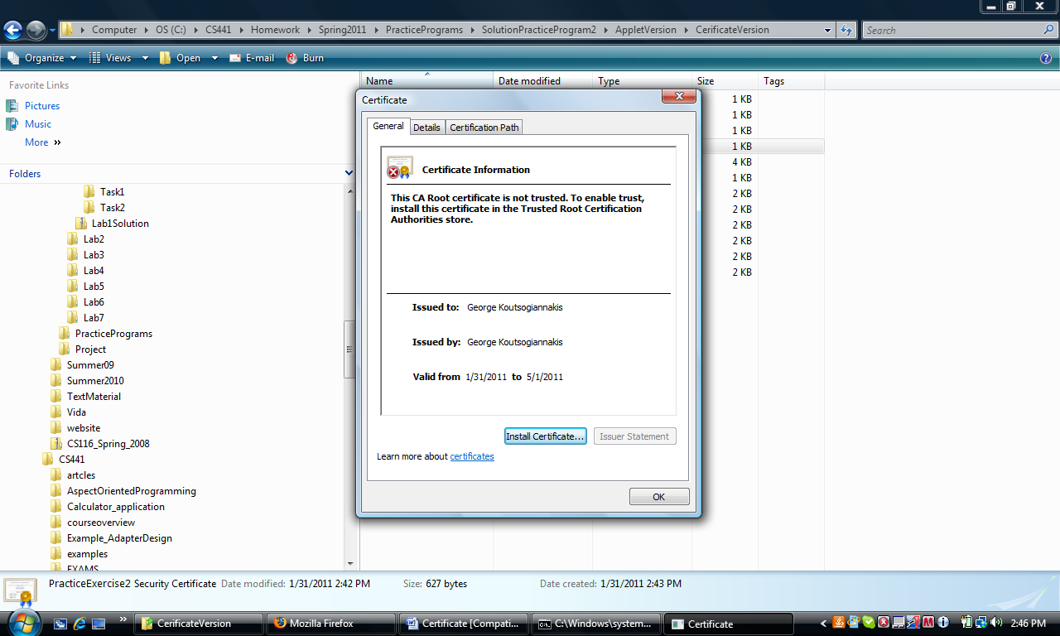

If you click on the certificate file icon you get the above display. You can click on install certificate e or you can proceed with the next step

STEP 3

Go to Program Files/Java/jdk1.6.0/jre/lib/security. Place the certificate file MycertificateName.cer in that directory.
Execute the following command in a DOS window in the security directory:

>keytool –import –alias MyTrustedCertificate –keystore cacerts –file MyCertificateName.cer
Note that the alias in this command is not youralias generated at the beginning of this process.
Enter keystore password: changeit (Note that changeit is the password for cacerts keystore located in the security directory of the jdk).

i.e.
C:\Program Files\Java\jdk1.6.0_14\jre\lib\security>keytool -import -alias MyTrustedCertificate -keystore cacerts -file PracticeExercise2.cer
Enter keystore password:
Owner: CN=George Koutsogiannakis, OU=Computer Science, O=IIT, L=Chicago, ST=Illinois, C=US
Issuer: CN=George Koutsogiannakis, OU=Computer Science, O=IIT, L=Chicago, ST=Illinois, C=US
Serial number: 4d471cad
Valid from: Mon Jan 31 14:33:49 CST 2011 until: Sun May 01 15:33:49 CDT 2011
Certificate fingerprints:
MD5: A5:1E:65:5F:89:AD:70:28:57:95:D3:79:53:16:03:D3
SHA1: 90:DC:13:09:EA:4B:13:E3:B0:E5:E1:C3:8D:14:0E:F1:35:50:1D:5F
Signature algorithm name: SHA1withRSA
Version: 3
Trust this certificate? [no]: yes
Certificate was added to keystore
keytool error: java.io.FileNotFoundException: cacerts (Access is denied)

STEP 4

Jar the applet class

>jar cf MyJarredAppletClass.jar *.class (you have to be in the same directory as the applet class)
Or instead of .* you can list the specific bytecodes file like MyApplat.class
MyJarredAppletClass is the name that you want the jar file to have.

STEP 5

Create the signed jar now

>jarsigner –signedjar sMyAppletclass.jar MyAppletclass.jar youralias
You will be asked for the passwords you entered in step 1 at the very top of these instructions.

NO Policy File is needed ( unless you want to include one)!!If you want a policy file enter the keystore and the signer in the policy file entries.

Changes to the applet code do not require re-issuance of the certificate but the jar file and the signed jar file have to be regenerated

