MORTGAGE CALCULATOR GRIB BAG LAYOUT MANAGER
SEE SOURCE CODE FOR DETAILS. MARKED SIZES OF COMPONENTS ACCORDING TO SOURCE CODE OF THE MORTGAGECALCULATION.JAVA GRID BAG LAYOUT VARSION. NOTICE THAT THE COMPONENTS SHOWN CAN HAVE OTHER COMPONENTS INSIDE THEM (BOXED).
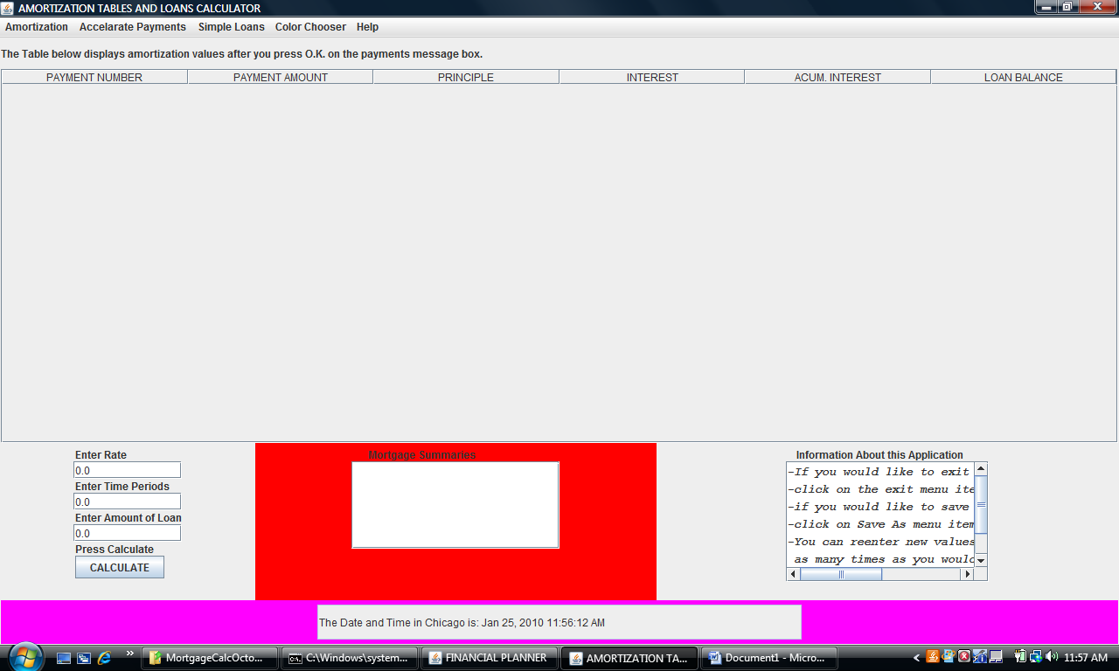
JLabel: tablelabel
Size: 800 by 20
Column: 0, row: 0
Gridwidth: 40
gridheight: 1

JScrollpane: myscrollpane
Size: 800 by 400
Column: 0, row: 1
Gridwidth: 40
gridheight: 20

MyPanel: panel
Size: 300 by 300
Column: 10, row:21
Gridwidth: 15
gridheight:15

JPanel: paneleast
Size: 300 by 300
Column: 25, row:21
Gridwidth: 15
gridheight:15

JPanel: panelwest
Size: 200 by 300
Column: 0, row:21
Gridwidth: 10
gridheight:15

JPanel: southpanel
Size: 800 by 80
Column: 0, row:36
Gridwidth: 40
gridheight:4

